National Association of Flour Distributors | 2019-2020
Cooperation Between Manufacturers & Distributors Through Mutual Understanding |  | Membership  www.thenafd.com

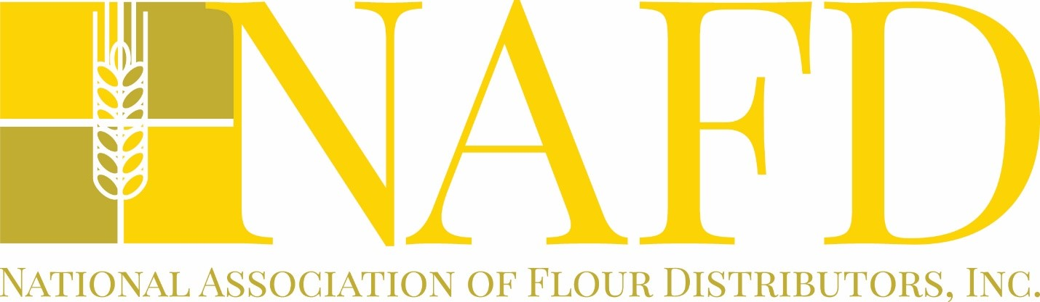
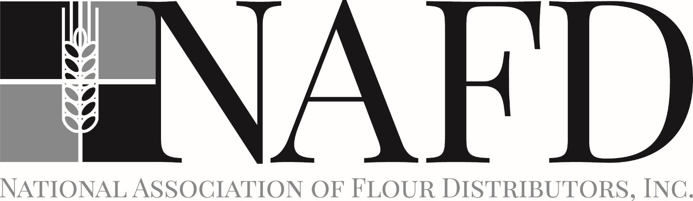
The National Association of Flour Distributors (NAFD) was formed in 1919. Our organization is comprised of flour and bakery products distributors and suppliers from throughout the USA, Canada, Jamaica and the Dominican Republic. Distributor members purchase over $2 Billion of bakery ingredients and products each year and are represented by owners and officers from both single facility independent distributors and distributors with multiple distribution facilities. In addition, Allied (Supplier) members, national, regional and local, are valuable members and contributors to the NAFD. Miller (flour) members include representatives from all major flouring milling companies in the USA. A list of companies that have member representatives can be found on page six. If you are a distributor or if you already do or want to do business with any of the NAFD distributors, you should join our association of industry leaders.
Membership is based upon the individual, therefore, many companies have multiple members. Members receive an annual Membership Directory; our publication The Flour Distributor semi-annually; the ability to attend the NAFD Annual Convention which includes industry specific, leadership and economic business programs, as well as, the opportunity to meet and share ideas with top leaders in our industry and supply chain. Through the NAFD, members also become affiliated with the National Association of Wholesaler-Distributors (NAW), which offers numerous educational and business benefits. In addition, each member receives electronically, The Kiplinger Letter weekly and Kiplinger’s Personal Finance Adviser monthly.
Those who have joined us at our annual convention have found the cost of attendance is immensely exceeded by the value. Where else can one meet in a business and social environment with the top leaders in our industry in one forum? One supplier estimated that it would take him almost $50,000 in travel to have this much opportunity, assuming he could even get the contact. As an industry leader, we hope you will choose to join other baking products manufacturer and distributor leaders who find great value in and contribute to our organization.
MEMBERSHIP
“The board shall have the authority to categorize each member according to his/her employer’s focus and/or their roles within their employer’s organization. At the discretion of the board, this classification may be used to set the rights and responsibilities of each member.”

Member Categories

- Distributors – A person classified as a distributor is one who spends 51% or more of his/her time, and/or whose business unit enjoys 51% or more of its revenues, from re-selling bakery-related products to non-consuming customers.

- Millers – A person classified as a miller is one who is employed by a company, or segment of a company, that employs the milling process of wheat as the basis for 51% or more of its revenue.

- Allied – Allied members are those who, as a focus of their business, sell goods and/or services to the baking industry but are not millers or distributors, as defined above.

- Retired - Any NAFD member in good standing who retires from, or otherwise leaves, the baking industry and its allied industries. Should a retired member re-enter the industry, he/she must re-apply for membership according to his/her new employment status.
- Membership is from August 1st through July 31st (NAFD Fiscal Year)
- A membership is for an individual – not company. Companies are encouraged to have multi-members.

A previous NAFD member who has missed more than one year as a member, must resubmit for approval as a new member.
OUR MISSION

The Mission of the NAFD is to serve the interests of its members who are engaged in the flour industry and those companies allied thereto by providing educational, professional, and networking opportunities by:

- Holding meetings and conferences for the mutual improvement and education of its members.

- Developing and encouraging the practice of high ethical standards among members serving our industry.

- Collecting and disseminating information helpful to its members.

- Exchanging and compiling information with respect to all new laws and other local and legislative developments at the state and local level which affect our industry.

- Providing opportunities for the exchange of ideas and information concerning the flour industry for study and discussion.

Each of these activities substantially contributes to the success of our members and the accomplishments of the NAFD and provides the mechanism for future activities.

PURPOSE

The purposes of this organization are to foster trade and commerce and the interests of those having a common trade, business, financial or professional interest, to secure freedom from unjust or unlawful exaction’s, to procure uniformity and certainty in the customs and usage’s of trade and commerce, and of those having a common trade, business, financial or professional interest; to settle and adjust differences between its members and others, and to promote a more enlarged and friendly intercourse among businessmen to advance the civic, commercial, industrial and agricultural interest of the territory where the corporation is situate and of the territories of its various members; to promote the general welfare and prosperity of such territories and to stimulate public sentiment to those ends; to provide such civic, commercial, industrial, agricultural and social features as will promote these purposes; and to do any other act or thing incidental to or connected with the foregoing purposes or in advancement thereof.

ANNUAL CONVENTION

In 2019, we celebrated our 100th annual convention, Wednesday - Sunday the week following Mother’s Day. Upcoming events include:

- May 13 – 17, 2020 – Omni Hilton Head Oceanfront Resort, Hilton Head Island, South Carolina
- May 12 – 16, 2021 – The Ritz Carlton, Amelia Island, Amelia Island, Florida

OPPORTUNITY & VALUE

Distributor
Forum for Discussion and Learning
- Procedures
- Processes
- Problem Resolution
- Regulations
- Technology
- Training
- Industry Issues
- Relationships
Supplier
Forum for Opportunity
- Principals & Executives
- Rapport Outside the Office
- The Human Relationship
- Learning What Makes a Distributor Successful
- Sharing Ideas
- Problem Resolution at the Highest Level
NAFD Challenge
Fulfill the Mission:
- Educate
- Stimulate
- Participate
Improve our industry
- Spread the Word of the NAFD Opportunity and Success
DISTRIBUTOR LOCATIONS

DISTRIBUTORS (40 Companies with Over 70 Locations and Over $2 BILLION in Ingredient and Product Purchases)

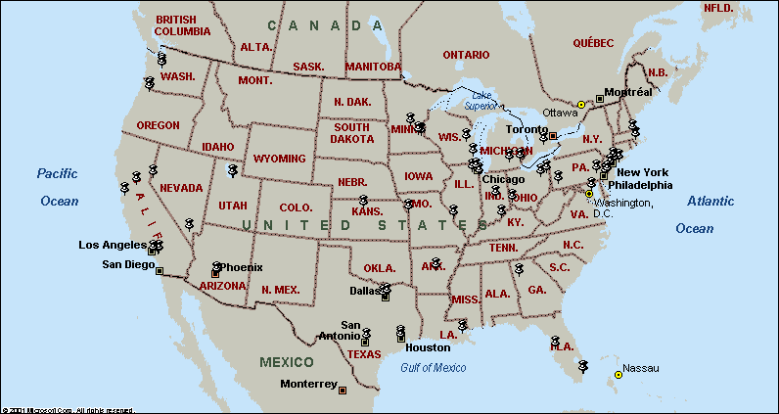

NAFD Board of Directors & Committees

CHAIRMAN OF THE BOARD

ERIN M. RUHL
Hanover, MD

OFFICERS

MARK R. MUNROE – President
Greenville, WI

NICHOLAS DEPALMA – 1st Vice President
North Bergen, NJ

ASHLEY KOERNER TURNER – 2nd Vice President
New Orleans, LA

ERIC METZENDORF - Secretary/Treasurer
Jackson, MI

BOARD OF DIRECTORS

OFFICERS

Mark R. Munroe
Nicholas DePalma
Ashley Koerner-Turner
Eric Metzendorf

IMMEDIATE PAST PRESIDENTS

Steve Tardella
Chicago, IL

Philip S. Zilka
Belle Vernon, PA

Erin M. Ruhl
Hanover, MD

ALLIED REPRESENTATIVE

John Johansen

Saddle Brook, NJ

MILLER REPRESENTATIVE

Karen F. Horton
Troy, NY

ADVISOR TO THE BOARD

Robert M. Olender
Royal Oak, MI

ELECTED BOARD MEMBERS

J. Gerard Burns

St. Louis, MO

Matthew Brehm, Jr.

Yonkers, NY

Duane Bruinsma

Crete, IL

Anthony J. Fodera
Corona, NY

James Gallagher, Jr.
Reading, PA

Theodore (Ted) Heim, Jr.
Deer Park, NY

R. David Scruggs, Jr.
Little Rock, AR

John D. Traynor
Hamilton, ON, Canada

2018 - 2019 STANDING COMMITTEES

Executive – Mark Munroe, Nicholas DePalma, Ashley Koerner-Turner, Eric Metzendorf, Erin Ruhl

Nominating – Steve Tardella, Philip Zilka, Jr., Erin Ruhl

Finance & Audit – David Scruggs, Jr.

Membership & Publicity – Ashley Koerner Turner, Mark Munroe, John Traynor, Karen Horton, John Johansen, Jeffrey Barnhart

Government Regulations & Trade Practices – Eric Metzendorf

Constitution & By-Laws – Theodore Heim, Jr., Robert A. Olender, Matthew Brehm

OTHER COMMITTEES

Material Handling – Rich Wise & Alan Gardner

Liaison to NAW – Eric Metzendorf & Theodore Heim, Jr.

Convention Site – Mark Munroe, Nicholas DePalma, Ashley Koerner-Turner, Eric Metzendorf, Erin Ruhl

Technology – Ashley Koerner-Turner

Education – Eric Metzendorf

Historical – Timothy Dove

2nd Century: Steve Tardella, Robert Olender, Gerry Burns, Ashley Koerner Turner, Tom Houlihan, David Fliss, Theresa DePalma, Jeremy Heim

For additional Information contact:

ASSOCIATION EXECUTIVE
Tim Dove
Association Services USA
5350 Woodland Place, Canfield, OH 44406
Phone: (330) 718-6563 Fax: (877) 573-1230
E-mail: timdove51@gmail.com

NAFD FISCAL YEAR - AUGUST 1 – JULY 31 Dues Payable by August 31
NAFD MEMBERSHIP DUES - $350 PER YEAR
MEMBERSHIP APPLICATIONS ARE AVAILABLE AT:
www.THEnafd.com

DISTRIBUTORS
NAFD Representation by Company Affiliation
(40 Companies with over 70 Locations and over $2 BILLION in Ingredient and product purchases)
A. Oliveri & Sons, Inc.
BakeMark LLC
Batory Foods
Bono Burns Dist., Inc.
Capitol Food Company
Central Baking Supplies, Inc.
Colony Foods Inc.
Commercial Associates Ltd.
David Rosen Bakery Supplies
Dawn Food Products Inc.
Fodera Foods
George R. Ruhl & Son, Inc.
H.F. Scruggs Co., Inc.
ImperialDade
Inter-County Bakers, Inc.
JAR Bakers Supply Inc.
John E. Koerner & Co., Inc.
Johnson Brothers Bakery Supply
KB Ingredients LLC
L. V. Lomas Limited
Lentz Milling Company
Niagara Distributors
NTD Ingredientes
Otto Brehm, Inc.
Perkins Company
Puratos Bakery Supply
Rohtstein Corp.
Rudolph
SBS Foods Inc
Sidco Food Distributors
Siegel Egg Company
South Holland Paper
Sparta Bakery Supplies Inc.
Tardella Foods, Inc.
Traynor’s Bakery Wholesale
US Flour Inc.
Valente Yeast Company, Inc.
Valley Cooperative Assoc.
Zilka & Co. Bakery Supplies
SUPPLIERS and OTHER ALLIED
Abel & Schafer Inc.
Advantage Solutions
Agricor
AIB
American Almond Products Co, Inc.
Association Services USA
BakeMark LLC
Bake'n Joy Foods
Barry Callebaut & American Almond
Byrnes & Kiefer Co.
Caruthers Raisin Packing Co., Inc.
Clabber Girl
Clofine Dairy & Food Products, Inc.
Corbion
Corporate Alternatives
CSM Bakery Solutions
Dakota Blenders Inc.
Dawn Food Products Inc.
Domino Foods, Inc.
Efco Products, Inc.
Fruit Fillings Inc.
General Mills/Pillsbury
Golden Boy Foods
Gold Star Transportation
Guittard Chocolate Company
Hughson Nut, Inc.
I. Rice & Co. Inc.
IFC Products
International Bakers Services, Inc.
International Foods & Ingredients
Lallemand-American Yeast Sales
Lawrence Foods
Legacy Foodservice Alliance
Lesaffre Yeast Corporation
Malt Products Corporation
Michael Foods
Paul Esposito, Inc
PNF & Associates Inc.
Prime Pastries
SUPPLIERS and OTHER ALLIED (con’t)
Puratos
Rich Products/Flavor Right
Satin Fine Foods
Sosland Publishing Company
Southern Champion Tray, LP
Stratas Foods, LLC
The Hemisphere Group, Inc,
The PROgram
Tri State Specialties
Ultra Trading International LTD
Valores Alimenticios of America
Ventura Foods, LLC.
W. A. Cleary Products
Win-Win Brokerage
FLOUR MILLS
ADM
Ardent Mills
BayState Milling
General Mills
Grain Craft
Giusto's Specialty Foods, LLC
Italgrani USA
King Arthur Flour
Miller Milling
North Dakota Mill
Panhandle Milling
Siemer Specialty Ingredients

If you know of a company that should be represented in the most dynamic organization in our industry, please give them an application or have them call Tim Dove @ 330-718-6563 or e-mail: timdove51@gmail.com

Testimonials

“My 15 years as a member of the NAFD has not only provided me with access to the top decision makers in our industry, but also the opportunity to grow strong personal relationships with these leaders. The experiences and knowledge that I have gained through the NAFD have been invaluable to the growth of my family owned business. Being a member has not only benefitted me professionally but also personally through the friendships I have built.”

Erin Ruhl
Vice President
George R. Ruhl & Son, Inc.
Hanover, MD

“I‘ve been a member of the NAFD for over 30 years. The annual NAFD convention brings together leaders from distributors, flour millers and other prominent suppliers to the baking industry. Through my participation along with members of my leadership team, we’ve fostered long-standing business relationships, and developed deeper understandings of the challenges and opportunities in our industry. I’ve always come away from the annual meeting with new information and ideas that help to drive our business forward.”

Eric Metzendorf
President – Distribution
Dawn Food Products Inc.
Jackson, MI

“The NAFD is a special organization. It has been successful for so many years because it is based on friendship, friendship between distributors, both non-competitors and competitors, friendship with industry representatives and friendship between families. Maybe the family friendships are the secret, because the spousal participation is a unique aspect of the NAFD. It provides a relaxed social atmosphere where business gets done with a handshake and a smile. When Linda and I attended our first convention we were heartily greeted and included in every activity. We quickly discovered that our business was not unique and was a mirror image of the other distributors in attendance. We all had similar problems with trucks, computers, sales compensation, etc. Everyone openly discussed problems and solutions down to the minor detail --- priceless information that a consultant could never provide. And nothing has changed over the years. We still have open discourse about our ever changing business challenges. Again---priceless.”

Earl Koerner
Chairman
John E. Koerner & Co., Inc.
New Orleans, LA

"Efco has been a member of the NAFD for many years. The annual conference is without a doubt a can't miss event where you have the chance to develop lasting business and personal relationships. The opportunity to meet with industry leaders to share ideas has paid dividends far greater than the cost of attendance. If you are in the baking industry you should be a member of this organization."

David Miller
VP Sales & Marketing
Efco Products, Inc.
Poughkeepsie, NY

“At Ardent Mills, we are committed to supporting the National Association of Flour Distributors, and the benefits that it provides. As a member for over 25 years, the relationships, contacts and business information that has been provided was extremely valuable to our company. I would recommend membership to any supplier within the industry.”

Peter Bisaccia
Sr. Director of Sales
Ardent Mills
Yorktown Heights, NY

“I have been attending the NAFD conventions since 1995. I have always felt the organization has benefited our business by creating an environment to network with customers and others within the baking industry. The conventions have allowed me more insight into the industry. The meetings are informative and have given me valuable information that I can bring back to benefit our business. I would recommend this organization to anyone who is involved in flour milling, bakery suppliers and distributors.”
Steve Sannes
North Dakota Mill

National Association of Flour Distributors Inc.
2019-20 Membership Application (Fiscal Year August 1, 2019 – July 31, 2020)

Current Members (CHANGES ONLY) – If your information as it appears in the Membership Directory is accurate, you only need to complete your name.
Name of Applicant: Name of Spouse/Companion: (As it is to appear in Directory)
Last Name _________________________________ Last Name
First Name First Name ________________________
Middle Initial
Title
Company ______________________________
Mailing Address: Alternate Address: Business/Home (if different):
Street Street ____
City ______ __ _ City ____________ ____
State Zip _______ State Zip
Country _____ Country ____
Contact Phone ___Ext __ Alternate Phone
Mobile/Cell Fax _________ _________________________
E-Mail Address
Business Category (check one): Please Identify Your Status (check one):
Distributor Other (Describe) 2018-19 Member Renewing Membership
Allied (Suppliers of Products or Services) _______________________ First Time Member
Flour Miller _______________________ Honorary Member
Retired _______________________ Previous Member (Renewing after lapse in membership) _____________________________________________________________________________________
DUES: $350.00 (Payable in U.S. dollars)
PLEASE MAIL PAYMENT & APPLICATION TO:
NAFD (Fed ID#: 39-6091438)
5350 Woodland Place
Canfield, OH 44406

Credit Card payments will incur a 3% service fee.
Send application and request to Ashley.Koerner@Koerner-Co.com for processing.
_____________________________________________________________________________________________

MEMBERSHIP
“The board shall have the authority to categorize each member according to his/her employer’s focus and/or their roles within their employer’s organization. At the discretion of the board, this classification may be used to set the rights and responsibilities of each member.” Dues are payable by August 31st each year. Late payment may result in exclusion from the NAFD Membership Directory which is printed in the fall.
Please check this box if you do not wish to have your Membership Data shared with other NAFD members or the NAW.
ANNUAL CONVENTION
Mark your calendar for the 2020 Convention at the Omni Hilton Head Oceanfront Resort; Wednesday May 13 - Sunday May 17.
This is your invoice
Please Pay by August 31
Please identify Member’s Name(s) in payment documentation.

